# **Project Report: Home Services App**

## **1. Introduction**

The *Home Services App* is designed to connect users with trusted local service providers such as plumbers, electricians, cleaners, handymen, HVAC technicians, and painters. The application provides a modern UI, easy navigation, and service categorization to make booking professionals simple and efficient.

## **2. Background Study**

Nowadays, people rely on digital platforms to find verified professionals for household tasks. Traditional methods such as word of mouth or local posters are time-consuming and often unreliable. Platforms like UrbanClap (now Urban Company) and TaskRabbit have popularized on-demand home service systems. Inspired by these, our project focuses on building a Flutter-based mobile application integrated with authentication and service browsing features.

## **3. Requirement Analysis**

### **Functional Requirements**

1. **User Authentication**: Login & Registration for users and providers.
2. **Browse Services**: View services like Plumbing, Electrical, Cleaning, etc.
3. **Search Functionality**: Search by service type and location (zip code).
4. **Popular Services Chips**: Quick access to trending services.
5. **Provider Listing**: View a list of service providers.
6. **Join as Provider**: Service providers can register themselves.

### **Non-Functional Requirements**

1. **Responsive UI**: Supports both small and large devices.
2. **Performance**: Smooth navigation and optimized loading.
3. **Scalability**: Can be extended with more services and features.

### **Tools & Technologies**

1. **Frontend**: Flutter (Dart)
2. **Backend**: Supabase (Authentication + Database)
3. **IDE**: VS Code / Android Studio
4. **Platform**: Android, iOS  
   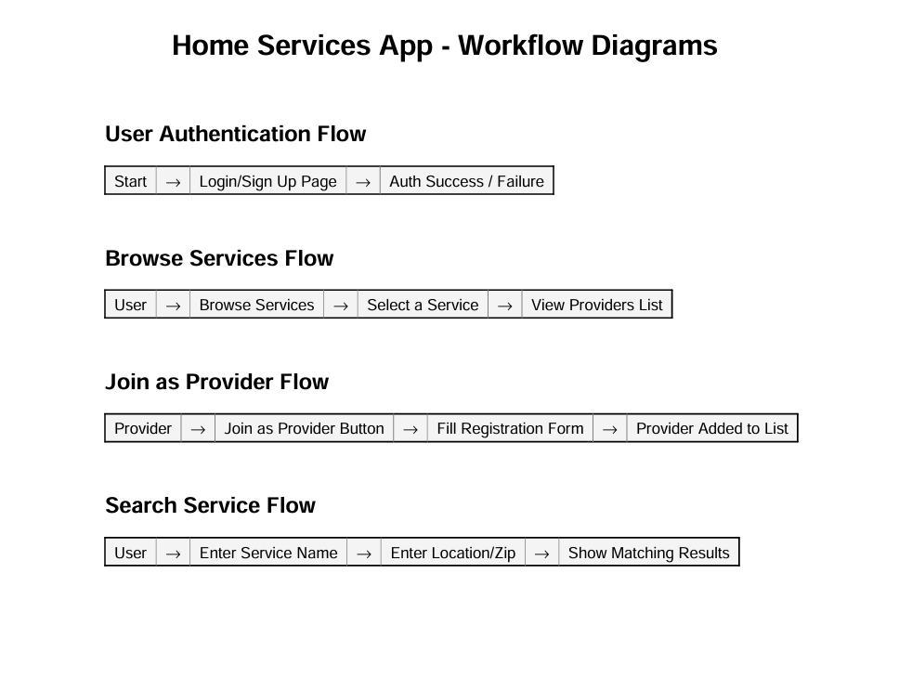

## 

## 

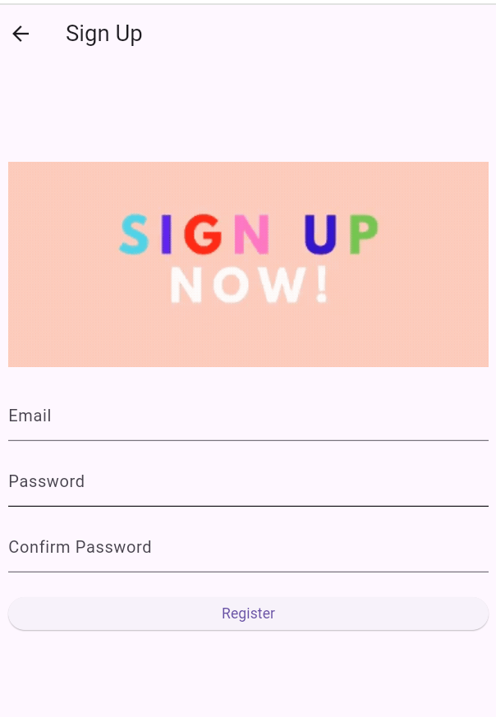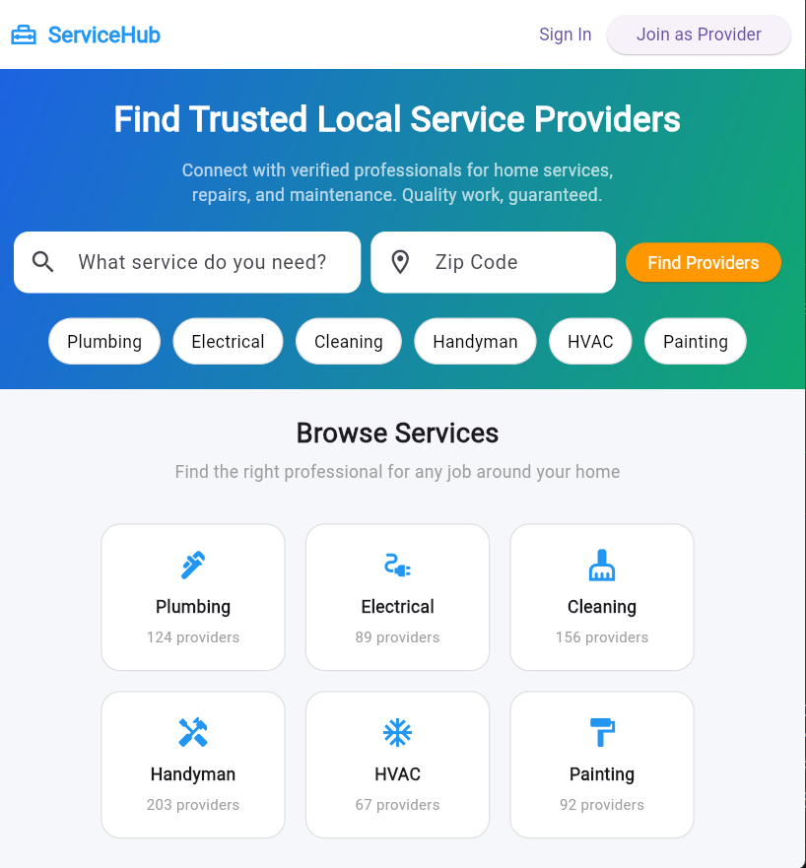

## 

## 

## 

## **6. Future Work**

* **Booking System** – Allow users to directly book providers.
* **Payment Gateway** – Secure online payments.
* **Ratings & Reviews** – Users can rate and review providers.
* **Provider Dashboard** – Manage services, bookings, and earnings.
* **Push Notifications** – For job confirmations and updates.
* **Admin Panel** – Manage users, providers, and services.

## **7. Conclusion**

The Home Services App successfully provides a **platform for users and providers to connect easily**. It ensures verified professionals, user-friendly design, and scalable features. Although currently limited to browsing and provider registration, the system is well-structured for future enhancements like booking, payments, and reviews. This project can serve as a foundation for a full-scale commercial home service marketplace.

👉 Ekhon bol, tumi chao naki ami **report ta nicely formatted PDF** baniye dei screenshots er placeholder soho?